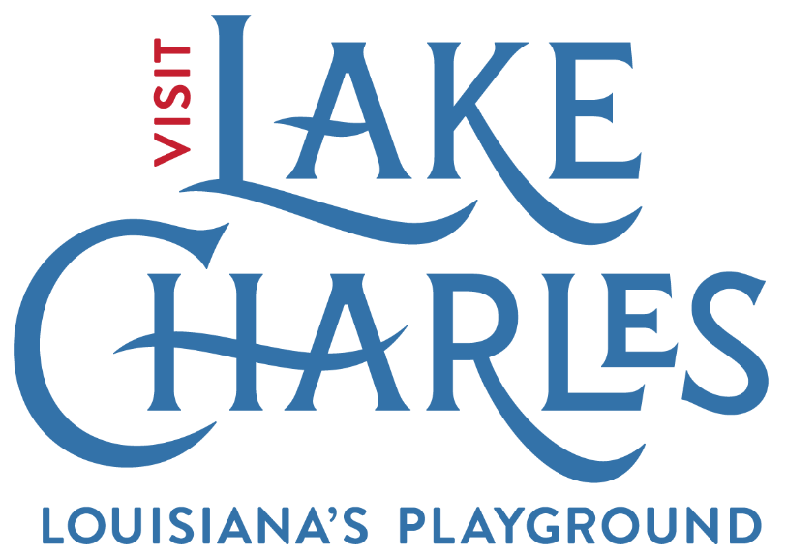 **SWLA Convention**

**&**

**Visitors Bureau**

**Tourism Marketing**

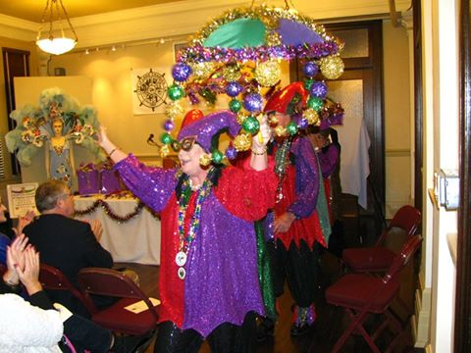

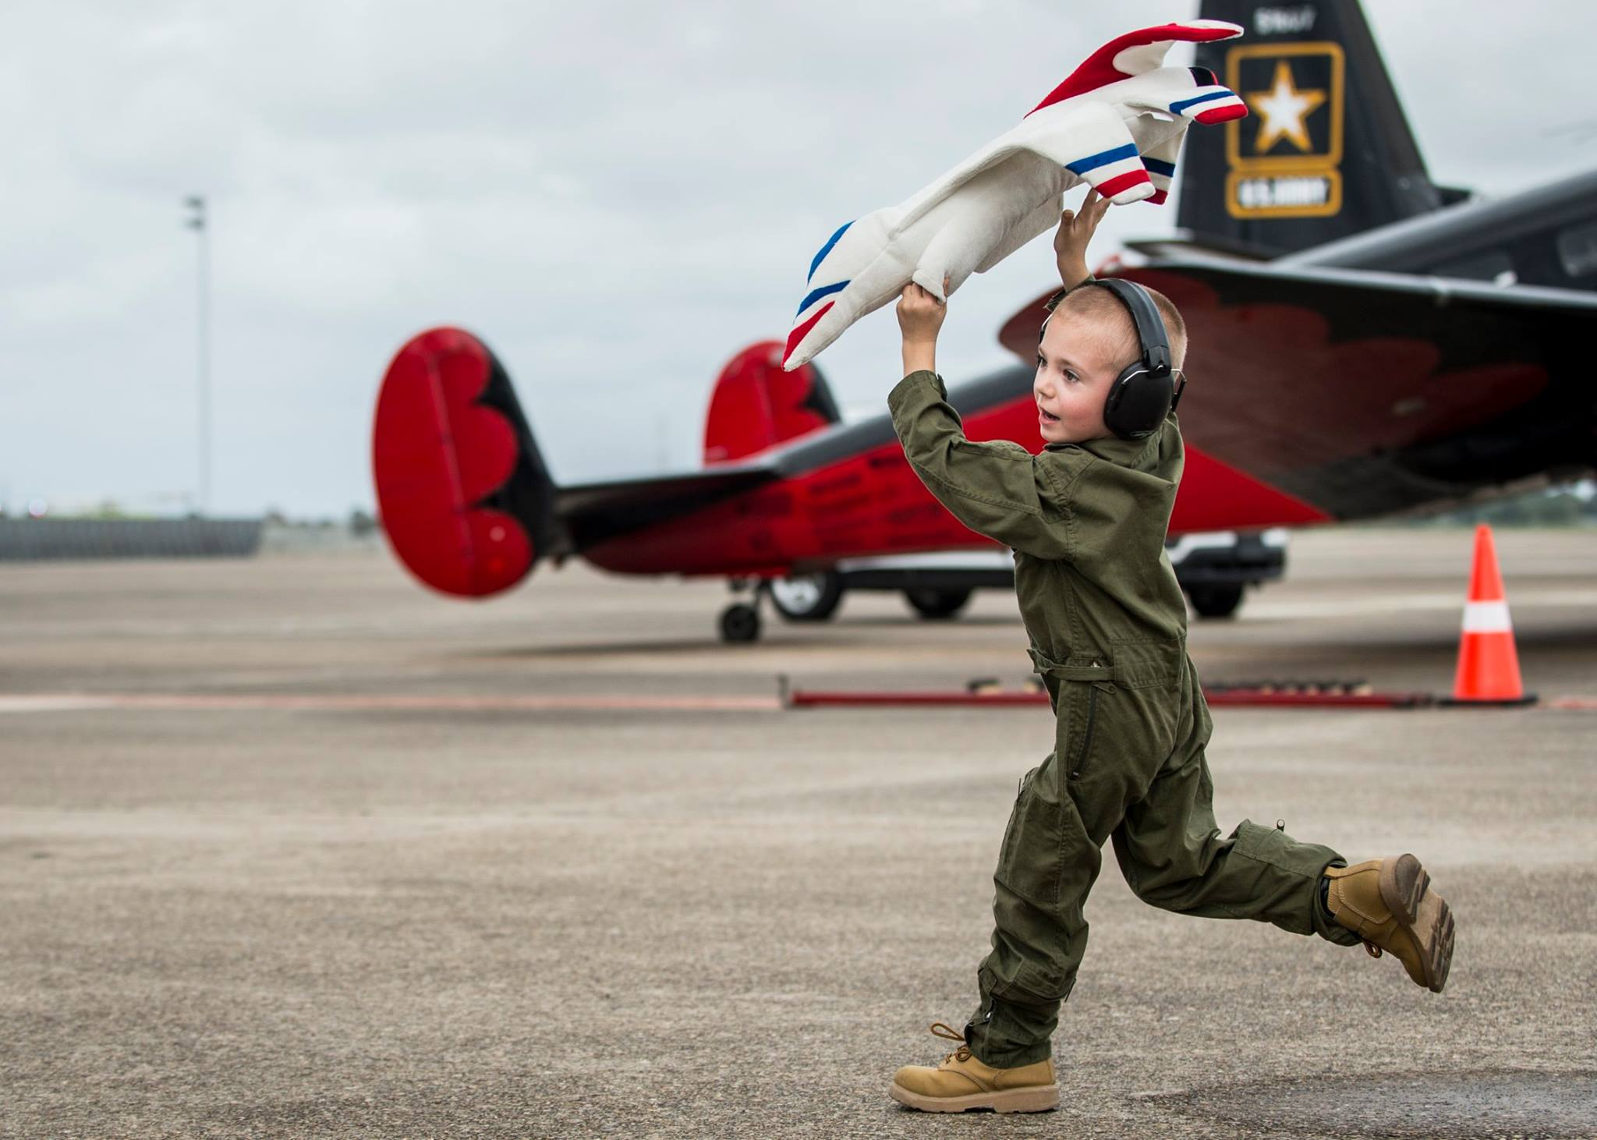

**GUIDELINES  
FY 2022-2023**

**Activity Period**

**June 15, 2022-June 14, 2023**

***funded by***

**Visit Lake Charles**

**Lake Charles/SWLA**

**Convention & Visitors Bureau**

***administered by***

**Arts & Humanities Council**

**Grant**

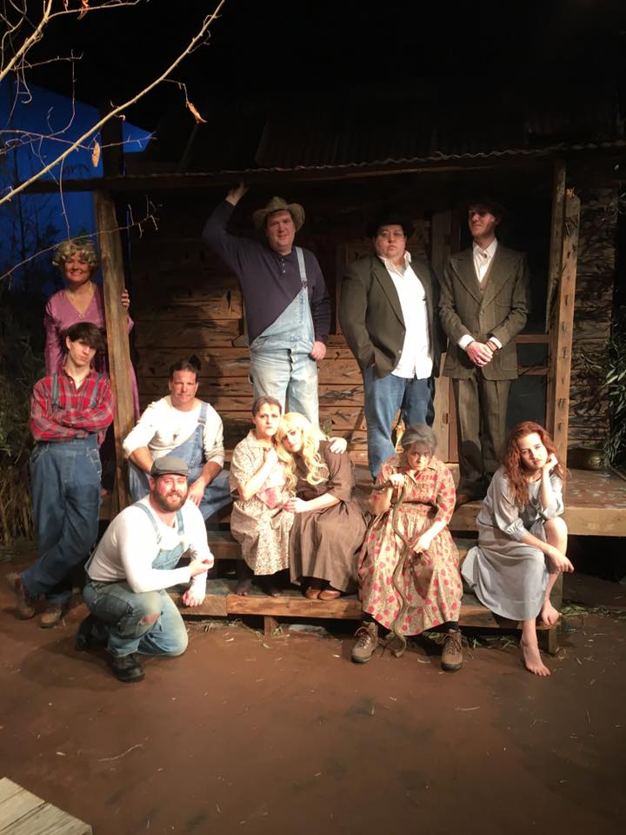







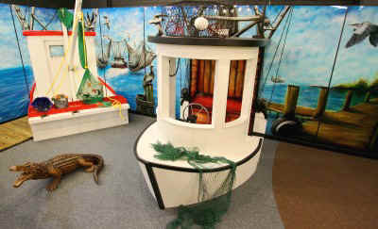

**APPLICATION REQUIREMENTS**

**Application Deadline – Friday, May 27th, 2022**. Application with original signed documents must be submitted via email to [jordang@artscouncilswla.org](mailto:jordang@artscouncilswla.org) by 5 p.m. on Friday, May 27th, 2022.

* Application can be downloaded at https://artscouncilswla.org/grant-opportunities/tourism-and-marketing-initiative-grant-program/
* Applicants must submit the original signed grant application with *blue signatures.
  + *Note: Electronic signatures will also be accepted.
* **All projects must take place between June 15th, 2022, and June 14th, 2023.**

**PLEASE NOTE: Free assistance** with your grant application is

provided by the Arts Council prior to submission. The Arts Council

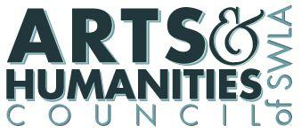

staff is available to assist applicants during any stage of the grant

writing process, from designing an eligible project to reviewing a

final draft of the grant application. The Arts Council office is open

Monday through Friday, and is currently located at 1111 Ryan Street, Lake Charles, LA.

Contact Jordan Gribble, Community Development Coordinator,

at jordang@artscouncilswla.org for questions and assistance.

**WHAT TYPES OF GRANTS ARE AVAILABLE?**

Eligible organizations may apply for one marketing assistance grant for a specific arts project. **Applicants may submit one request, of a minimum of $500 and not to exceed $2,000.** Cooperative projects that involve two or more organizations may submit one application that is separate from an application that any of the involved individual organizations may be submitting.

**A dollar-for-dollar cash match from non-governmental sources is required for those projects that are income producing. Projects that are non-income producing may substitute the cash match requirement with documented in-kind services equal to the amount of the grant request.**

Given the competitive nature of the grant process and the number of applicants, it is likely applications will



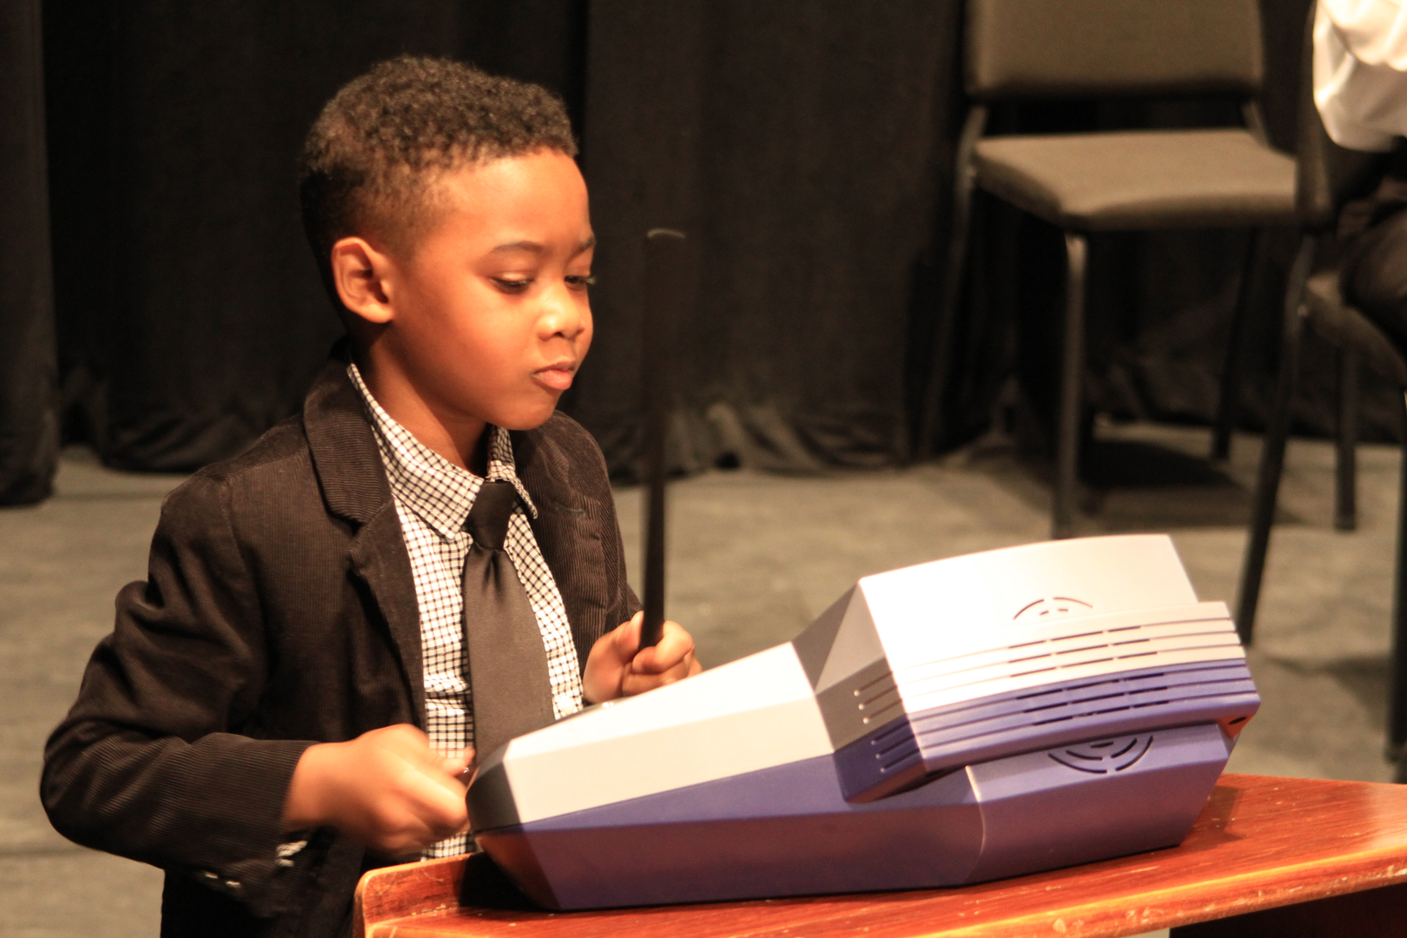

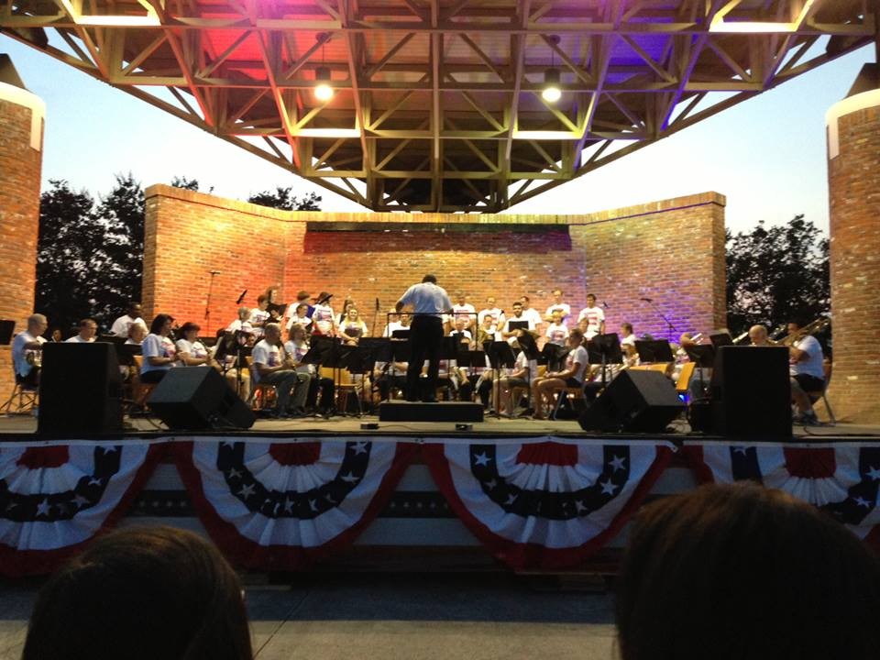

not be fully funded, if at all. It is important to consider additional sources of funding.

**WHO IS ELIGIBLE TO APPLY?**

**All applicants *must* be domiciled within Calcasieu Parish**. Applicants ***may not*** apply for ***projects that will occur outside of Calcasieu Parish***. The official domicile is the applying organization’s official address registered Louisiana Secretary of State and is indicated on the Certificate of Incorporation. All nonprofit organizations must be in good standing with the Louisiana Secretary of State. To check your organization’s domicile address, visit <https://coraweb.sos.la.gov/CommercialSearch/CommercialSearch.aspx> to search your organization’s profile.

**Fiscal Agent**

A Fiscal Agent is defined as a non-profit organization, acting on behalf of a sub-applicant, assuming responsibility for the legal and fiscal management of funds granted for use by a sub-applicant. A Sub-Applicant is an individual artist or organization lacking legal status to be an applicant who makes arrangements for another organization to act as its legal applicant. The fiscal agent agrees to submit and sign the grant application on the Sub Applicant’s behalf and to pass on such grant funds for project implementation. Please note that in such cases the applicant remains legally and financially responsible for the use of the grant funds.

**Fiscal Agent Requirements:**

1. Organizations may serve as a fiscal agent for only ONE other applicant – termed sub-applicant – in addition to their own application;
2. Fiscal agents must be domiciled in Calcasieu Parish; and
3. Fiscal agents may not serve as a provider of service within the same project.

**Non-profit arts, humanities, or cultural organizations domiciled in Calcasieu Parish are eligible to apply for funds. Organizations must be tax-exempt under Section 501(c)(3) of the Internal Revenue Service Code or be a public agency. During a calendar year, any organization that receives grant funds from any Lake Charles/SWLA Convention & Visitors Bureau (CVB) program may not apply for other grants available from the CVB.**

**USE OF GRANT FUNDS**

Grant funds shall be used in ***one or more*** of the following areas:

* Advertising and promotion efforts to expand attendance at arts and cultural events and to inform the public of new or existing events that are appropriate for the tourism market;
* Co-operative advertising directed to incoming visitors to Calcasieu Parish;
* Brochure development and printing for a festival, attraction, or other cultural program or event. Membership or other brochures used primarily for fundraising by an organization shall not be considered eligible under this grants program.
* Other eligible expenses include:
  + Website or other web-based design or development;
  + Digital or print billboards;
  + Printing for programs, flyers, handbills, posters, or other promotional print materials;
  + TV or radio commercials
  + Public relations, press kits
  + Print or online advertising;
  + Special advertising or promotional items
* All brochures should be available to the public at least sixty (60) days prior to the event/season promoted within. In addition, any print materials supplied to the **CVB** should be accompanied by a distribution list that indicates when and where the materials should be used.
* All applications should involve marketing industry professionals as appropriate for the project (advertising, graphic design, printing, public relations, etc.). Additionally, all project applications should address the organization’s distribution and marketing plan created as a result of the project.

**EVALUATION CRITERIA**

**Evaluation Criteria**

A review panel will evaluate your proposal using evaluation criteria, which will be used to determine recommended funding. Responses to the narrative questions provided in the application along with the project budget and provider of services will be evaluated accordingly. Your application will be reviewed based on the following evaluation criteria:

**Artistic Merit**

* Artistic Merit of the proposed project;
* Expertise of artists involved as providers of services;
* Contribution to the art form or the understanding and appreciation of the art form(s) proposed;

**Need and Impact**

* Need for the project in the community;
* How the project will contribute to expanding or improving Calcasieu Parish’s cultural tourism;
* Efforts for increased access, participation, and exposure to the arts;
* Involvement of diverse (social, geographic, economic) populations reflective of the community, including those with limited access to the arts;
* How the project demonstrates a positive local economic impact.

**Planning and Design**

* Well-planned and designed project;
* Relationship of project to cultural tourism;
* Realistic time frame as proposed;
* Level of community collaboration or involvement;
* Clear plan for distribution of marketing materials.

**Implementation**

* Quality of the implementation of grant funds towards marketing and promotions;
* Expertise of professionals and resources utilized with grant funds;
* Effective implementation of marketing plan.

**Administration and Budget**

* Ability of applicant to administer and deliver activities proposed;
* Appropriate request level and use of funds;
* Clarity and completeness of financial information;
* Compliance with past grant contracts, if applicable.

**Bonus Points**

Applications are eligible to receive the following bonus points. These points are added to the grant review panel’s total score for the application.

**5 Points: ______ Please check if 4 or more formats of advertising are used (and denoted in the application) to carry out the goals of the project, event, or organization. For example: billboards, flyers, social media, media, etc.**

**5 Points: ______ Please check if 80% of the businesses used (and denoted in the application) to carry out this project are Calcasieu Parish businesses. To claim this bonus point advantage, the business names and mailing addresses must be included in the grant final report.**

**Any organization claiming bonus points to secure a grant that does not provide proof of eligibility will have penalty points applied to the organization’s next SWLA Convention & Visitors Bureau Tourism Marketing Grant application.**

**WHAT DOES MY ORGANIZATION SUBMIT?**

1. Complete the application on the forms provided. No handwritten applications or incomplete applications will be accepted. Applications are available online and can be completed or downloaded at [**www.artscouncilswla.org**](http://www.artscouncilswla.org)**.**
2. **All applicants *must* submit the following:**
   1. Completed original application form with *original signatures.
      1. *Note: Electronic signatures are also acceptable.
   2. Proof of nonprofit status: Attach an IRS letter determining nonprofit tax exemption under Section 501(c)(3) of the Federal Tax Code or a letter from the Louisiana Secretary of State’s office if the organization does not have tax exempt status.
   3. Proof of parish domicile: Certificate of Incorporation from the Secretary of State’s office indicating the city in which the registered office of the applicant is located. Must show the most recent address as indicated on the Annual Report filed with the Secretary of State.
   4. Print a copy of your Business listing from the Secretary of State’s website showing your organization is in good standing.
   5. Board of Directors list including names, addresses, phone number, identifying officers, ethnic make-up, and professional affiliation.
   6. Year-end financial statement for the previous year ***OR*** the most current IRS Form 990 OR previous year’s P&L Statement.
   7. Samples of previous marketing materials.
   8. A copy of the current year’s operational budget.
   9. All applicants are encouraged to submit letters of support for this project/event.

**HOW ARE FUNDING DECISIONS MADE?**

After the **May 27th, 2022** deadline, the **Arts & Humanities Council** determines that the applicant and the proposal are eligible for funding, and that the application complies with grant guidelines. Two to three weeks later, eligible applications will be reviewed by the Arts Council and CVB grant allocation panel with respect to the published evaluation criteria. Panel recommendations will then be submitted to the Arts Council board of directors for final approval.

Once the panel has met, applicants may call the granting agency to find out the recommended funding level and panel comments. Applicants not recommended for funding or recommended for reduced funding may appeal the funding recommendation by submitting a written appeal to the Arts Council. For an application to be considered for appeal, the organization must submit a letter **justifying** the appeal. Such requests must contain a justification indicating that the decision against funding the project was based upon insufficient or incorrect information resulting from an issue other than the fault of the applicant.

Submitting an incomplete application is not grounds for appeal. Information not provided in the original grant application will not be considered as grounds for appeal. Recommendations by the panel to not fund an application or recommendations for partial funding are not grounds for appeal. The date that the funding recommendation will be available, and the appeal deadline will be included in the letter notifying applicants that their application has been received. Once the appeals have been reviewed, the Arts Council Board of Directors will be presented with the recommendations of the panel for final approval.

**WHAT DO I DO IF I’M FUNDED?**

**Contract and Payment Requirements**

Congratulations! You will enter into a contract with the Arts & Humanities Council. Applicants who receive partial funding should be prepared to revise the plan and budget accordingly. Once the contract has been signed and approved by all parties, you will be eligible to receive your first payment of 75% of your grant award. **If at any time, you are unable to complete the project, programs, or services for which you are funded, immediately contact the Arts & Humanities Council at (337) 439-2787.**

**Final Report Requirements**

During your project, you are responsible for keeping track of information and financial information related to your project, programs, or services for which you received grant money. You must keep copies of all receipts, invoices, check numbers, and cancelled checks.

The final report form will be available on the Arts Council website, and it will document the programs or services provided by your organization. Information in the final report should show attendance, gate, revenue generated, list of hotel rooms used and dates of bookings, a breakdown of how grant funds were used, and an evaluation of the success of the criteria detailed on the original application. Once you have submitted the final report with all required documentation and it has been approved, you will receive the final 25% of your grant award. **Final reports must be submitted to the Arts Council no later than thirty (30) days after completion of services or by July 30, 2023, whichever comes first.**

**Miscellaneous Requirements**

Organizations funded through this grant program are **required** to credit the Lake Charles/SWLA Convention & Visitors Bureau and the Arts & Humanities Council by name, logo, and/or credit statement in all relevant and appropriate printed public material (brochures, flyers, banners, etc.). High resolution logos for the Lake Charles/SWLA Convention & Visitors Bureau and the Arts & Humanities Council are found online under the Tourism Marketing Grant Program page at [www.artscouncilswla.org](http://www.artscouncilswla.org). Acknowledgement statements should be included in materials distributed to the public and must read as follows:

**Supported by a SWLA Convention & Visitors Bureau**

**Tourism Marketing Grant from the**

**Lake Charles/SWLA Convention &Visitors Bureau**

**as administered by the Arts & Humanities Council of SWLA.**

In addition, Grant recipient agencies ***are required*** to provide a current members & patrons list which shows membership at the appropriate dollar level. The Lake Charles/SWLA Convention & Visitors Bureau and Arts Council should be included in the organization's listings of members and patrons, with respect to the level of grant funds awarded. You **should also** **invite** those individuals responsible for funding your project, program, or service, including the Southwest Louisiana Convention & Visitors Bureau Board Members and the Arts & Humanities Council SWLA, by contacting:

Shanna Landry Devan Corbello

Director of Administration Executive Director

Visit Lake Charles Arts & Humanities Council SWLA

SWLA Convention & Visitors Bureau 809 Kirby Street, Ste. 202

P.O. Box 1912 Lake Charles, LA 70601

Lake Charles, LA 70602

If the Arts Council determines that a grantee has failed to comply with the terms and conditions set forth in the agreement, that grantee shall become ineligible to receive its final payment of 25% of the grant award. Recipients in non-compliance status may also be asked to return all or some of their initial grant payment. For one year following a determination of non-compliance, the grantee will be ineligible to apply to the SWLA Convention & Visitors Bureau Tourism Marketing Grant Program or any other grant program administered by the Arts Council.