
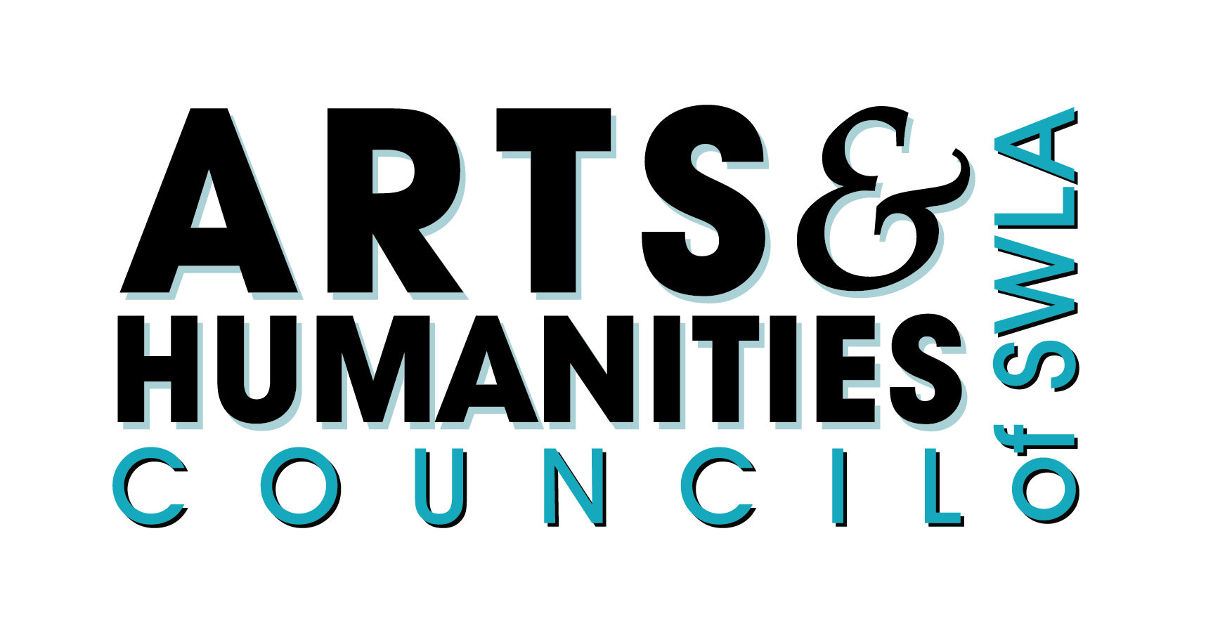
Light Up The Lake Christmas Celebration
Holiday Art Walk
Saturday, November 30
VENDOR CONTRACT

To reserve your spot for this year’s event please return by November 15.
- Completed copy of the vendor contract
- Payment
art/Merchandise vendors $50

The City of Lake Charles & Arts & Humanities Council of SWLA permits ______________________________________ the right to operate a vendor booth during Light up the Lake.

- No motor vehicles will be allowed to park behind any booth. All trucks must unhitch from their trailers! After unloading, park in nearby parking lots.
- Space is limited and will be assigned by event staff.
- You will receive one 8ft table and two chairs. You must provide your patio tent or umbrella for shade, and additional tables/chairs.
- Items to be sold by vendors must be approved by the Light up the Lake Committee.
- In consideration of the right to operate a vendor booth, the Arts & Humanities Council of SWLA will receive a fee as stated above.
- Move-in will begin at 10:00 am.
- Vendor booths must be open for business by 11:45 am on November 30. The program at the pavilion will begin at noon.
- Vendor booths may not be dismantled before 7:30 pm.
- In case of inclement weather, the event will be held inside the Event Center.
- Food vendors must furnish to the City of Lake Charles a Certificate of Insurance with Product Liability naming the City of Lake Charles as “additional insured”.
- ITEMS REQUESTED TO BE SOLD ARE AS FOLLOWS:
______________________________________________________________________________

______________________________________________________________________________

______________________________________________________________________________

ORGANIZATION NAME: ___________________________________________________

CONTACT NAME: ________________________________________________________

MAILING ADDRESS: ______________________________________________________

CITY: _________________________________ STATE: _______ ZIP: ______________

CELL PHONE: ___________________________________________________________

EMAIL _________________________________________________________________

BOOTH SIZE: Width: ______(feet) Length: ______(feet)
*The vendor fee covers 10’ x 10’ booths. Any booth larger than that will be subject to higher fees.

RETURN TO: Erica Barrios
Arts & Humanities Council of SWLA
809 Kirby St., Suite 202
Lake Charles, LA 70601
O: 337-439-2787
ericab@artscouncilswla.org

_______________________________________ _____________________________
Signature Date

